**Req_ PO5_LED STRING ANIMATION Tail Module_CDD**

**1- Status table:**

|  |  |  |  |
| --- | --- | --- | --- |
| **Version** | **Status** | **Author** | **Date** |
| **1.0** | **Draft** | **Menna Mostafa** | **5/3/2020** |

**2-History table:**

|  |  |  |  |
| --- | --- | --- | --- |
| **Version** | **Author** | **Date** | **Change** |
| **1.0** | **Menna Mostafa** | **5/3/2020** | **Initial creation** |

**3-Reference Documents:**

|  |  |  |  |
| --- | --- | --- | --- |
| **Reference No** | **Document Name** | **Version** | **Status** |
| **1** | **P05_Led String_SRS** | **1.6** | **proposed** |
| **2** | **P05_Led String_GDD** | **1.3** | **Draft** |

**4-Module description:**

Responsible for continuously reading the TAIL switch status and output signal LEDS Tail status ON/OFF.

**5-Software Context diagram:**

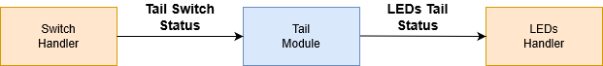

**6-API**

1-

|  |  |
| --- | --- |
| **Req. ID** | Req_PO5_LSAN_GDD_007_V01 |
| **Req. Coverage** | Req_PO5_LSAN_SRS_024_V02 |
| **API Prototype** | ERROR_STATUS Tail_init(); |
| **Description** | This API is responsible for initializing the TAIL switch at which pin |
| **Input Parameters** | Void |
| **Output Parameters** | ERROR_STATUS {OK = 1, NOK = 0} |

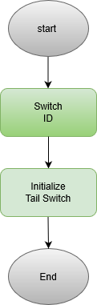

2-

|  |  |
| --- | --- |
| **Req. ID** | Req_PO5_LSAN_GDD_008_V01 |
| **Req. Coverage** | Req_PO5_LSAN_SRS_012_V02 , Req_PO5_LSAN_SRS_023_V01 |
| **API Prototype** | ERROR_STATUS Tail_getStatus(u8* Switch_Status ); |
| **Description** | This API is responsible for getting the TAIL switch state |
| **Input Parameters** | U8* Switch_Status {Pointer to a variable at which the status of the switch will be stored} |
| **Output Parameters** | ERROR_STATUS {OK = 1, NOK = 0} |

